**INTERSTATE CONTAINER CORPORATION** ***Date:* 06/13/2016** ***Spec #:***

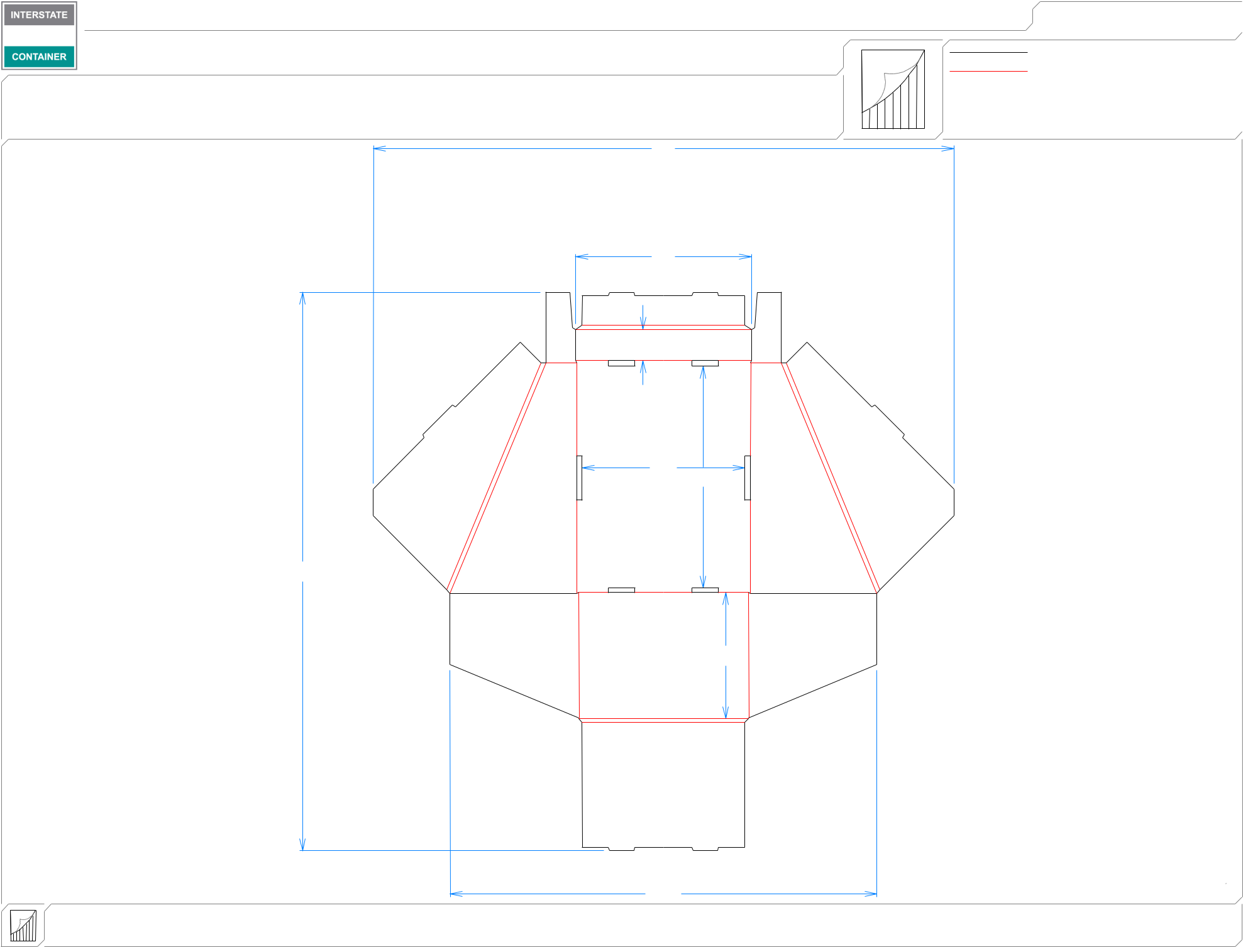

***Customer:*** **DeMet's Candy**

***Description:* Tray- New 6.4 oz Tray Holiday**

|  |  |  |  |  |  |
| --- | --- | --- | --- | --- | --- |
| ***Style:* NJDC** | ***Revision Info:* [0] 03/31/2016:** | |  |  |  |
| ***I.D. :* 9+1/4 x 12+5/8 x 7+1/8** | ***Blank size:*** | **31+3/4 x 66** |  |  |  |
| ***Board:* 32 B W** | ***Combination:*** | **36MW - 23M - 35HP** | ***Designer:*** | **Alan Groff** | |
|  |  |  |  | 33 |  |
|  |  |  |  | 10 |  |
|  |  |  |  | 13*/*4 |  |
|  |  |  |  | 91*/*4 | 125*/*8 |

313*/*4

73*/*16

|  |  |  |  |
| --- | --- | --- | --- |
| ***Design #:*** | **160389-01** |  |  |
|  |  |  |
| ***Cut*** | **330 in.** |  |  |
|  |  |
| ***Crease*** | **332 in.** |  |  |
|  |  |  |  |

|  |  |  |  |  |  |
| --- | --- | --- | --- | --- | --- |
| **inside view** |  |  | 241*/*4 |  |  |
| ***notes:*** |  |  |  |  |
| **Vertical Corrugation** | ***Qty/unit:*** | ***Area - waste:* 8.75 sq. ft** | ***Waste on blank:* 39.6%** | ***Piece weight - waste:* 0.92 lbs./415.34 g** |  |